Project - Low Level Design
On
Construction Planning Assistant Agent
Course Name: Agentic AI

Institution Name: Medicaps University – Datagami Skill Based Course

Student Name(s) & Enrolment Number(s):
Sr no | Student Name | Enrolment Number
1. | Ansh Kumbhare | EN22CS301140
2. | Anshul Sen | EN22CS301158
3. | Anshul Yadav | EN22CS301159
4. | Armi Bhawsar | EN22CS301194
5. | Athrav Dubey | EN22CS301229
Group Name: Group06-D2
Project Number: AAI-18
Industry Mentor Name:
University Mentor Name: Prof. Ajeet Singh Rajput
Academic Year: 2026

Table of Contents
- Introduction.
  - Scope of the document.
  - Intended Audience
  - System overview.
- System Design.
  - Application Design
  - Process Flow.
  - Information Flow.
  - Components Design
  - Key Design Considerations
  - API Catalogue.
- References

1. Introduction
This document presents the Low-Level Design (LLD) of the Construction Planning Assistant Agent project. It provides a detailed technical description of the system by breaking down its internal structure, components, and interactions within an agentic AI framework.
The purpose of this document is to define how the system is designed and implemented at a granular level. It includes detailed information about system modules such as task decomposition, dependency management, tool integration, and schedule generation.
The document serves as a blueprint for developers to understand the system architecture and for evaluators to assess the design approach used in the project. It ensures clarity in system implementation by describing how high-level construction goals are translated into detailed technical components, workflows, and execution plans.

1.1. Scope of the document
This document defines the detailed low-level design of the Construction Planning Assistant Agent. It describes the internal structure of the system, including its architecture, individual components, and their interactions within an agentic AI framework.
The document explains how the system processes construction-related goals, decomposes them into actionable tasks, validates constraints using integrated tools, and generates structured execution schedules.
It also covers the design of agents, tool integrations, process workflows, and data flow across the system. The purpose of this document is to provide a clear and comprehensive understanding of how the system is implemented at a technical level, enabling developers and evaluators to understand the functionality and design decisions of the application.

1.2. Intended Audience
This document is intended for:
- Developers implementing the system
- Academic evaluators and mentors
- Students studying Agentic AI
- Researchers exploring AI in construction planning
It helps the audience understand system design, workflows, and technical implementation details.

1.3. System overview
The system is a multi-agent AI-based Construction Planning Assistant that processes user-defined goals and generates structured construction execution plans.
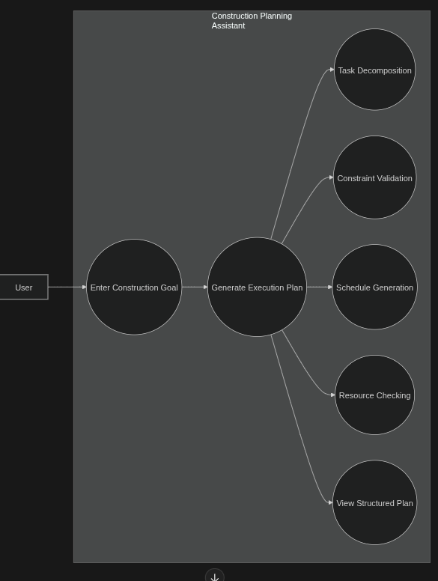
Figure 1: Use Case Diagram
Working Overview
- User provides a construction goal
- Planner Agent interprets the goal
- Goal is decomposed into smaller tasks
- Specialized agents perform specific planning functions
- Tools validate constraints such as resources, documents, and timelines
- Final execution plan is generated
Key Features
- Autonomous task decomposition
- Multi-agent collaboration
- Tool-based validation

2. System Design
The system follows a modular multi-agent architecture where each component performs a specific role. The design ensures flexibility, scalability, and efficient task execution.
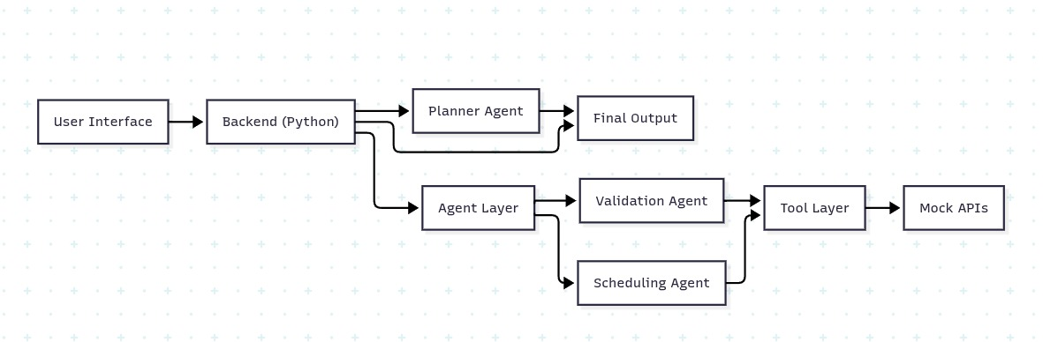
Figure 2: Architecture Diagram
Architecture Flow
User Input → Planner Agent → Task Decomposition → Specialized Agents → Tool Integration → Output
2.1. Application Design
The application consists of the following modules:
1. Input Module
- Accepts construction goal from user
- Validates and preprocesses input

2. Planner Agent
- Core decision-making unit
- Breaks goals into smaller tasks using LLM
3. Agent Layer
- Planning Agent: structures construction workflow
- Validation Agent: verifies constraints and feasibility
- Scheduling Agent: generates timeline and task order
4. Tool Layer
- Document Verification Tool
- Zoning Compliance Tool
- Resource Checker
- Timeline Estimator
5. Output Module
- Aggregates results
- Generates structured construction execution plan
2.2. Process Flow
The system follows a structured execution flow:
- User inputs construction goal
- System validates input
- Planner Agent decomposes the goal
- Tasks are assigned to agents
- Agents execute tasks
- Tools are used for validation
- Results are combined
- Final execution plan is generated

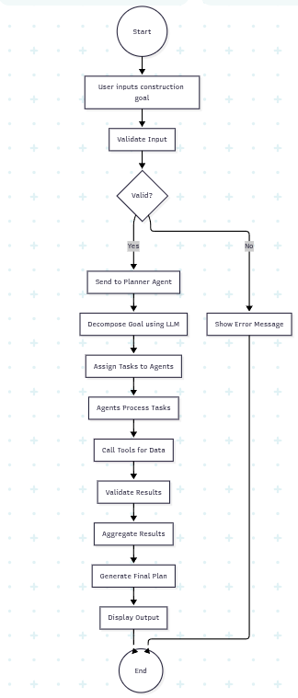
Figure 3: Activity Diagram

2.3. Information Flow
The flow of information in the system is as follows:
User Input
↓
Planner Agent
↓
Task List
↓
Agents
↓
Tool Calls
↓
Processed Data
↓
Final Output
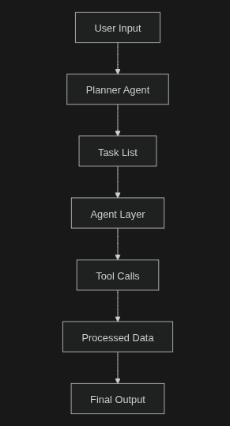
Figure 4: Flow Chart

Data Handling
- Input is processed and structured
- Intermediate data is shared between agents
- Final output is formatted for readability
2.4. Components Design
1. Planner Agent
- Responsible for task decomposition
- Uses LLM for reasoning and planning
2. Planning Agent
- Structures construction workflow
- Defines task dependencies and sequence
3. Validation Agent
- Verifies constraints such as documents, zoning, and feasibility
- Ensures compliance with construction requirements
4. Scheduling Agent
- Generates timelines for tasks
- Optimizes task order based on dependencies
5. Tool Layer
- Simulates external APIs
- Provides structured data for validation (documents, zoning, resources, timeline)
6. LLM Integration
- Uses Groq API
- Model: llama3-8b-8192

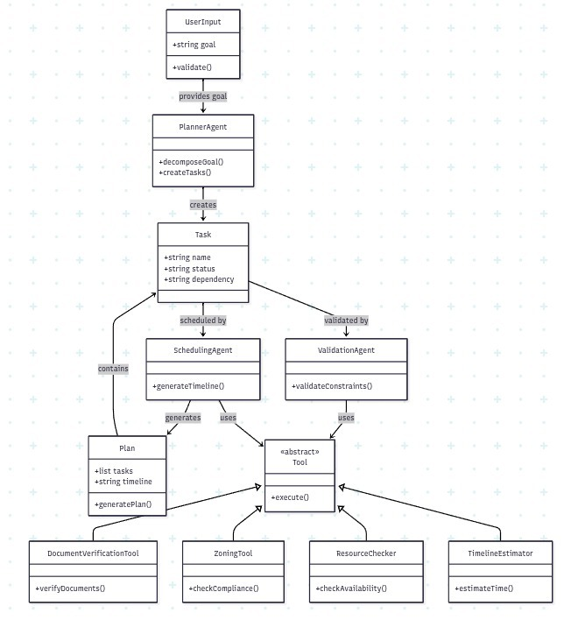

Figure 5: Class Diagram

2.5. Key Design Considerations
Scalability
The system can handle multiple agents and construction tasks simultaneously.
Modularity
Each component is independent and can be updated or replaced without affecting the overall
system.
Flexibility
New agents and tools can be integrated easily to support additional construction workflows.
Performance
Fast response is achieved using efficient LLM models and optimized agent interactions.
Reliability
Mock tools ensure stable execution without dependency on real external systems.
Security
No real project-sensitive or personal data is used, ensuring safe and secure operation.

2.6. API Catalogue
1. LLM API (Groq)
Parameter | Description
API Key | Authentication
Model | llama3-8b-8192
Input | Prompt
Output | Generated response

2. Document Verification API (Mock)
Input:
Document Type

Output:
Verification Status
3. Zoning Compliance API (Mock)
Input:
Location / Land Details
Output:
Compliance Status
4. Resource Checker API (Mock)
Input:
Resource Checker API (Mock)
Output:
Availability Status

5.Technology Stack

Category | Technology | Description
Programming Language | Python | Used for implementing agents, workflows, and backend logic
Agent Framework | CrewAI / LangChain | Used for multi-agent orchestration and tool integration
LLM API | Groq API (llama3-8b-8192) | Used for reasoning, task decomposition, and planning
Architecture Pattern | Agentic AI + RAG | Combines multi-agent reasoning with retrieval-based context
Vector Database | FAISS | Stores embeddings for context retrieval (RAG)
Memory Module | LangChain Memory / In-Memory Store | Maintains execution state and intermediate results
Tool Layer | Mock APIs (Permit Checker, Resource Validator, Cost Estimator, Timeline Generator) | Simulates external systems for validation and planning
Development Environment | Jupyter Notebook / Google Colab / VS Code | Used for development, testing, and debugging
Data Handling | JSON | Used for structured data exchange between components
Version Control | Git & GitHub | Used for code management and collaboration

3. References
- CrewAI Documentation
- LangChain Documentation
- Groq API Documentation
- Research papers on Agentic AI
- Construction planning and project management resources

